**Frontend Project Report**

on

# Ecommerce Shopping Site

# Using HTML, CSS and JavaScript

# Bachelor of Engineering

## in

**COMPUTER SCIENCE AND ENGINEERING**

Submitted by:

**Aanchal Sharma (Roll no: 2110990009)**

**Group-5**

Under the supervision of

**Mr. Lavish Arora, CSE Dept.**



**CHITKARA UNIVERSITY INSTITUTE OF ENGINEERING AND TECHNOLOGY**

**Rajpura, Punjab**

## Department of Computer Sc. & Engineering

### ACKNOWLEDGEMENT

I would like to extend our heartfelt gratitude to the individuals and organizations who played a significant role in the successful completion of my college front-end project developed with JavaScript, HTML, and CSS. Their invaluable support and contributions were instrumental in the creation of this project.

I would like to thank:

Our Instructor Mr. Lavish Arora, who provided me with guidance, knowledge, and the opportunity to explore and apply front-end development skills. His support and mentorship were indispensable throughout this project.

Open-Source Community: The open-source community, which provided an array of resources, libraries, and tools that made the development process smoother and more efficient. I greatly appreciate the open-source contributions that fueled my project.

College Support Services: The college's support services, including the library, IT department, and administrative staff, who made resources, facilities, and technical assistance available to me during this project.

This project allowed me to apply the knowledge and skills I acquired during my college education. It was a valuable learning experience, and I am grateful for the opportunities it provided.

I am committed to continuous improvement and the pursuit of knowledge in the field of front-end development. This project marks the beginning of my journey, and I am excited to take what I have learned into my future endeavors.

Thank you to everyone who contributed to this project's success.

Sincerely,

Aanchal Sharma

2110990009

Chitkara University

CONTENTS

----------------------------------------

Acknowledgement……………………………………………………………………….. i

Introduction………………………………………………………………………………..ii

Goal and Challenges…………………………………………………………..iii

Project Overview……………………………………………………………….. iv

Why choose ELECTRONICS……………………………………………….. v

Future Scope……………………………………………………………………….. vi

**CHAPTER 1: INTRODUCTION**

* 1. **Objective:**

Welcome to my college front-end project, a showcase of my skills and knowledge in web development. This project was created using JavaScript, HTML, and CSS to demonstrate my ability to design a user-friendly and visually appealing website. Our primary focus was on delivering an exceptional user experience while applying best practices in front-end development.

This project allowed us to apply what I have learned and gain practical experience in the field. It reflects my dedication to web development and showcases my problem-solving and skills. In the following sections, I will delve into the project's features and technologies used to bring it to life. Thank you for joining me on this journey through my project.

* 1. **Introduction to technology used to make project:**

To develop this project, HTML has been used majorly where different methodologies and tools were applied. Vs Code was the greatest help in developing the above project. More on the technologies and methods used for the project can be seen below:

**HTML:** HTML stands for Hypertext Markup Language. It is the standard markup language used to create and structure content on the World Wide Web. HTML is the backbone of most web pages and is used to define the structure, elements, and layout of a web page, including text, images, links, forms, and multimedia.

HTML uses a system of tags to mark elements on a web page. These tags provide instructions to web browsers about how to display the content. For example, you can use HTML tags to create headings, paragraphs, lists, links, and more.

**CSS:** CSS stands for Cascading Style Sheets. It is a stylesheet language used for describing the presentation and visual design of web pages written in HTML and XML. CSS allows web developers to control the layout, formatting, and appearance of elements on a web page, such as text, images, links, and more.

CSS achieves this by defining rules that specify how HTML elements should be displayed. These rules consist of selectors and declarations. CSS provides a wide range of properties and values that can control everything from colors and fonts to spacing, borders, and positioning. It allows web developers to create visually appealing and responsive web designs while keeping the HTML content separate from its presentation. This separation of content (HTML), presentation (CSS), and functionality (JavaScript) is a fundamental concept in web development, known as the "separation of concerns."

**JavaScript:** JavaScript is a versatile and widely used programming language primarily employed in web development but also increasingly used in other areas, such as server-side development and mobile app development. JavaScript allows developers to add interactivity, manipulate the Document Object Model (DOM), and enhance the functionality of websites and web applications.

Key features and uses of JavaScript include:

* Client-Side Scripting: JavaScript is primarily used on the client side of web development. It runs in the user's web browser, allowing developers to create dynamic and interactive web pages. It can respond to user actions, validate forms, update content, and much more.
* DOM Manipulation: JavaScript can access and modify the Document Object Model (DOM), which represents the structure and content of a web page. This enables dynamic content updates and interaction with HTML and CSS elements.
* Event Handling: JavaScript is used to respond to various events, such as clicks, keyboard input, and form submissions. This allows for user-friendly interfaces and responsive Ib applications.
* AJAX (Asynchronous JavaScript and XML): JavaScript is essential for making asynchronous requests to web servers, allowing data to be loaded and updated without requiring a full-page refresh. This technology is commonly used to create responsive, real-time web applications.
* Cross-Browser Compatibility: JavaScript is supported by all major web browsers, making it a suitable choice for web development. However, developers often use libraries and frameworks to address browser compatibility issues and streamline development.
* Server-Side Development: With the advent of technologies like Node.js, JavaScript can also be used on the server side to build server applications. This enables full-stack JavaScript development and simplifies the development stack for many projects.
* Front-End Frameworks: Several front-end JavaScript frameworks and libraries, such as React, Angular, and Vue.js, have gained popularity for building user interfaces and single-page applications. These frameworks provide a structured approach to building complex web applications.
* Back-End Development: JavaScript is used on the server side, along with Node.js, to create server applications and APIs. This allows for a consistent language and toolset throughout the entire web development stack.

JavaScript is a fundamental tool for modern web development, and its versatility and widespread use have made it an essential skill for web developers. It continues to evolve, with new features and improvements being added to the language and its ecosystem to meet the demands of modern Ib applications.

**VS Code:**

VS Code, short for Visual Studio Code, is a free and open-source code editor developed by Microsoft. It is widely used by developers for various programming languages and offers a rich set of features that enhance productivity and facilitate efficient coding.

Here are some key aspects and features of VS Code:

1**. Lightweight and Fast:** VS Code is designed to be lightweight and fast, providing a smooth and responsive coding experience. It uses minimal system resources and has quick startup times, making it suitable for both small and large projects.

2**. Cross-Platform Support:** VS Code is available for Windows, macOS, and Linux, allowing developers to use the same code editor across different operating systems. This ensures consistency and flexibility for development teams working on different platforms.

3. **Integrated Development Environment (IDE) Features:** Despite being a code editor, VS Code offers many IDE-like features. It provides code completion, syntax highlighting, linting, debugging capabilities, version control integration (such as Git), and more. These features enhance productivity and streamline the development process.

4**. Extensibility:** VS Code has a vast and active extension ecosystem that allows developers to customize and extend the functionality of the editor. Extensions are available for various purposes, such as language support, themes, code snippets, and integration with third-party tools and services.

5**. Integrated Terminal:** VS Code includes an integrated terminal, enabling developers to execute commands, run scripts, and interact with the command-line interface without leaving the editor. This eliminates the need to switch between the editor and an external terminal window.

6**. Version Control Integration:** VS Code seamlessly integrates with popular version control systems like Git, providing features like source code management, commit history visualization, and branch management. Developers can perform version control operations directly within the editor.

7. **Debugging Support:** VS Code offers powerful debugging capabilities with built-in support for various programming languages. It allows developers to set breakpoints, inspect variables, step through code execution, and track down and fix issues in their applications.

8**. IntelliSense:** VS Code provides intelligent code completion and suggestions, known as IntelliSense. It analyzes the code context and offers relevant suggestions, reducing manual typing and helping to catch errors early.

9**. Customization and Theming:** VS Code allows users to customize the editor's appearance, including themes, icon sets, and layout configurations. Users can choose from a variety of pre-installed themes or install additional themes from the extension marketplace.

10**. Remote Development:** VS Code includes remote development extensions that enable developers to work on a remote machine or container directly from the editor. This feature is particularly useful when developing on remote servers or in containerized environments.

Overall, VS Code has gained popularity among developers due to its flexibility, performance, and extensive customization options. Its broad language support and extensive marketplace of extensions make it suitable for a wide range of programming tasks and project types.

**CHAPTER 2: GOALS AND CHALLENGE**

**2.1 Goals:**

* **User-Friendly Interface:** Develop a responsive and user-friendly interface that allows customers to easily browse products, view details, and make purchases, ensuring a seamless experience on both desktop and mobile devices.
* **Attractive Product Presentation:** Present products in an appealing and organized manner, including high-quality images, detailed descriptions, and customer reviews, enhancing the overall shopping experience.
* **Efficient Navigation:** Implement intuitive navigation with clear categories, filters, and search functionality, enabling users to quickly find the products they are looking for without any hassle.
* **Smooth Checkout Process:** Design a streamlined and secure checkout process with multiple payment options, guest checkout feature, and real-time order tracking, minimizing cart abandonment and ensuring a smooth transaction flow.
* **Interactive Features:** Integrate interactive elements such as product sliders, image zoom, and quick view options, allowing customers to engage with products before making a purchase decision.
* **Personalization:** Implement personalized product recommendations and user-specific content based on browsing history and preferences, enhancing user engagement and increasing the likelihood of sales.
* **Performance Optimization:** Optimize website performance by minimizing loading times, optimizing images, and employing efficient coding practices, ensuring a fast and responsive website experience for users.
* **Mobile Responsiveness:** Ensure full compatibility and functionality across various mobile devices and screen sizes, providing a consistent experience for users accessing the site from smartphones and tablets.
* **Security:** Implement robust security measures, including SSL certificates and secure payment gateways, to safeguard customer data and instill trust in online transactions.
  1. **Challenges:**
* **Cross-Browser Compatibility:** Ensuring the website functions correctly and appears consistent across different web browsers (Chrome, Firefox, Safari, etc.) can be challenging due to varying rendering engines and standards.
* **Responsive Design Complexity:** Designing a responsive layout that adapts seamlessly to various screen sizes and orientations, including smartphones, tablets, and desktops, requires careful planning and testing.
* **Data Management:** Handling and displaying a large volume of product data, including images, descriptions, prices, and customer reviews, while maintaining website performance can be challenging.
* **Third-Party Integrations:** Integrating third-party services such as payment gateways, shipping providers, and customer relationship management (CRM) systems, while ensuring smooth communication and data exchange, can pose integration challenges.
* **Maintaining Codebase:** Keeping the HTML, CSS, and JavaScript codebase organized, scalable, and maintainable, especially as the project grows, is crucial to facilitate future updates and additions.
* **Accessibility:** Ensuring the website is accessible to users with disabilities by adhering to web accessibility standards (WCAG) can be complex and requires careful attention to design and functionality.
* **Performance Optimization:** Continuously monitoring and optimizing the website's performance, including load times and responsiveness, to provide a smooth user experience, especially as the site's content and traffic increase.
* **Security Vulnerabilities:** Protecting against common web security threats such as SQL injection, cross-site scripting (XSS), and data breaches requires constant vigilance and proactive security measures.

**CHAPTER 3: PROJECT OVERVIEW**

**Project name:** NOVOTECH

**Project topic:** Electronics E-commerce website

**Technologies used:** HTML, CSS, and JavaScript

**Total Number of Pages**: 20

**Total Time taken**: 3 months

**3.1 Project Preview:**

In the project that has been shown below, I have tried to create a website using HTML, CSS and JavaScript with a clean user interface which provides an easy shopping and exploring experience for the user. Colour and aesthetics of site has been kept simple and minimal to further increase user appeal. Different category pages are made for easier browsing to find your favourite in a nick of a time.

**3.2 Home Page:**

**• Header and Navigation (nav):** Website's header includes the brand name "NOVOTECH" with a

link to the home page. It also contains navigation links for different sections of website, such

as "Categories," "Contact us," "About us," a search bar, a "Sign Up" a “Login in” button.

**• Video Background:** Video is set to autoplay, muted, and loop. The video source (an MP4 file) is

provided within the source tag.

**• Today's Best Deals:** This section showcases various product deals. Each deal includes a

product image, name, price, specifications, and buttons for "Buy Now" and "Add to Cart." Also

there is sortby functionality to sort the product items:low-to-high , high-to-low.

**• Blog section:** There is a blog section that contains a series of articles, posts, or entries

written by the website owner or authors on various topics.

**• Connect with us:** There is a connect with us section in with users have the functionality of live

chat with “NOVOTECH COMMUNITY”

**• Top selling electronics & shop by Category:** Product slider shows top selling electronics of

the website and different categories.

**• Image Banner:** There is a gif showing different ads**.**

**• Shop from your favourite brands:** Section containing different options to shop by brand**.**

**• Image Banner:** There is a static banner showing Free Shipping,Authentic Items,Easy Returns etc.

**• Footer:** The footer section contains Company Information and a brief tagline, Home,About,

Services , Team , contanct , and facebook, instagram etc icons. 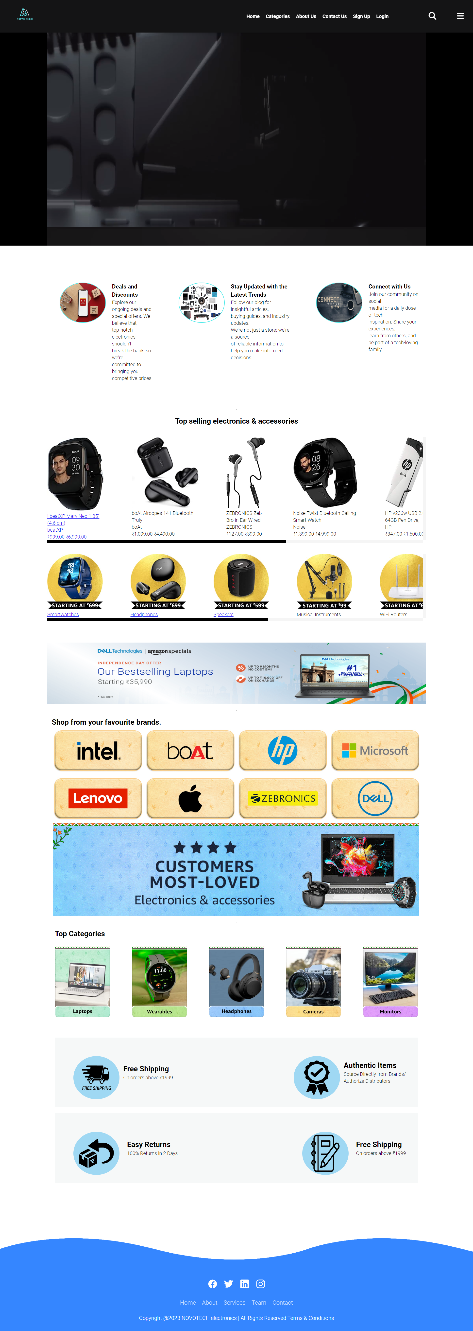

**3.3 About Us:**

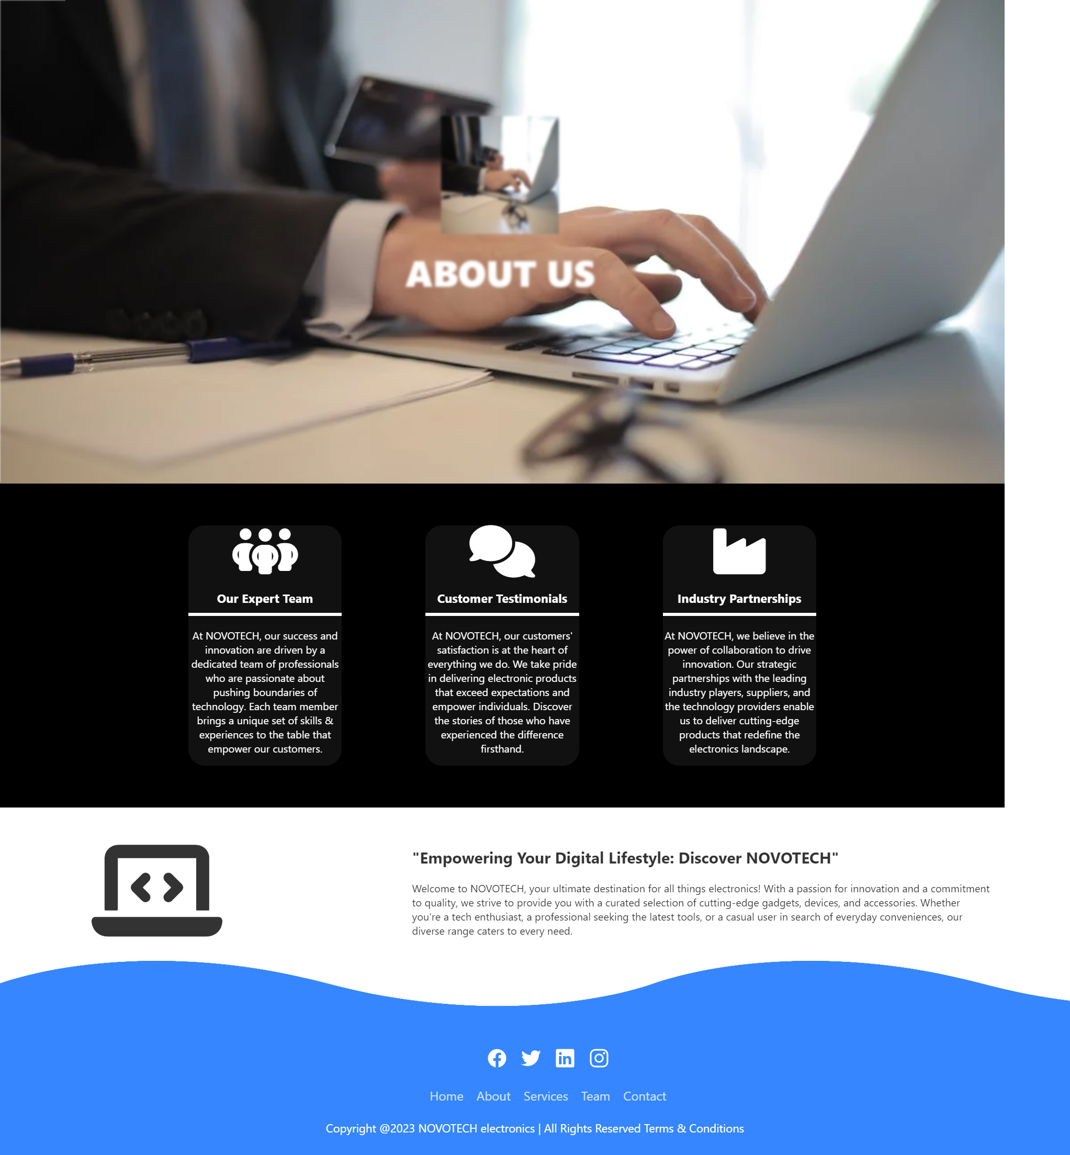1. The About Us page provides essential information about your brand and its mission.

2. It showcases my company's vision of shaping the future of e-commerce technology.

3. It emphasizes gaining insights into user demographics and preferences, fostering user engagement, and keeping users informed with personalized messages.

4. This data-driven approach is further underscored with statistics about user engagement, interactions, notifications, and orders.

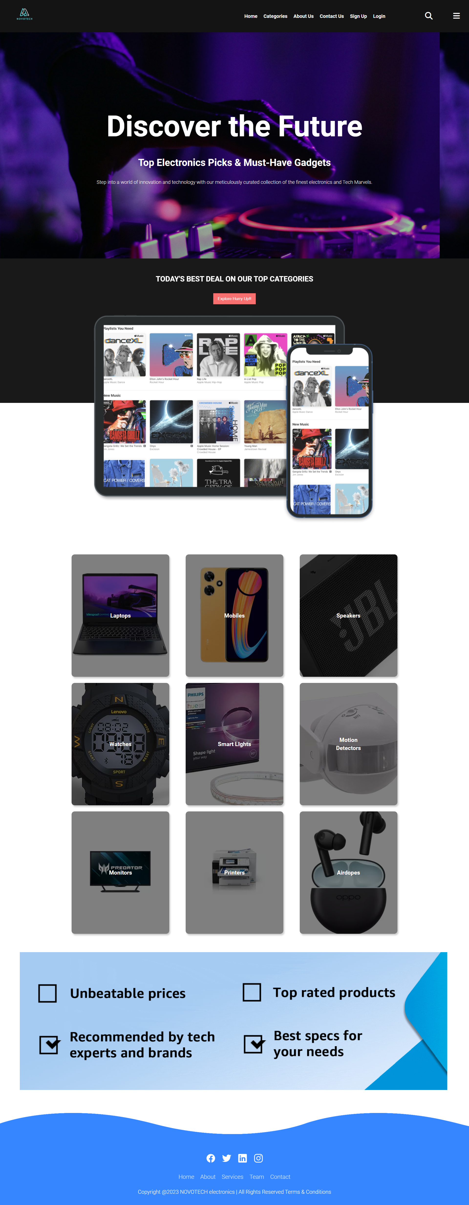

* 1. **Categories Page:**

1. The "Categories" page provides a clear and organized structure for users to explore and shop for products.

2. The page presents various product categories, each with a main subcategory and related subcategories, making it convenient for users to narrow down their product searches.

3. Overall, this "Categories" page is designed to streamline the shopping process, making it

easy for users to find and explore products in an organized and user-friendly manner.

* 1. **Contact Us Page:**

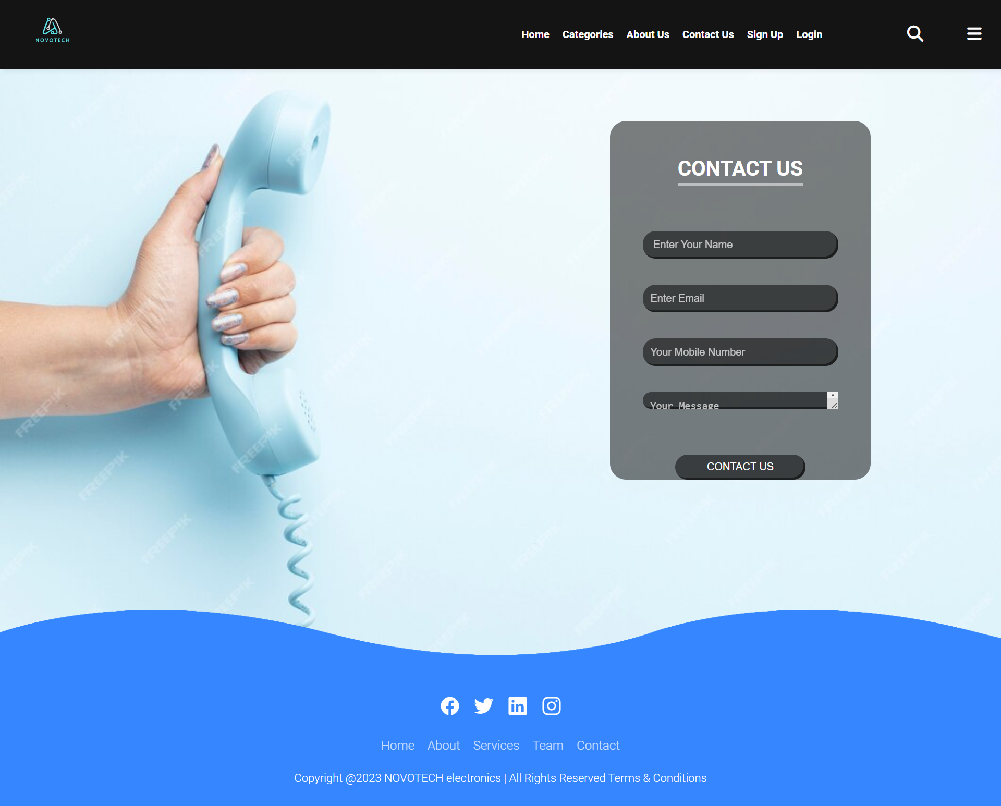

1. The "Contact Us" page serves as a vital communication channel between customers and the company. The header includes easy navigation, with "Contact Us" highlighted as the active section, making it straightforward for users to get in touch.
2. The main content of the page presents a contact form, allowing customers to reach out to the company. The form prompts users to provide their name, mobile number, email, and a message. This user-friendly interface facilitates effective communication. Additionally, the page features a map-like graphic to showcase your various office locations, along with addresses, making it convenient for customers to find us physically.
   1. **Signup / Login Page:**



1. The "Signup" page offers an intuitive and convenient way for users to create an account. The page maintains a clean and straightforward design, ensuring a seamless user experience. It presents a registration form that prompts users to provide their name, mobile number, email (optional), and a password of at least 6 characters.

2. The form encourages new users to sign up by providing essential personal information while keeping the process user-friendly. Additionally, the option to "Login here" is provided for those who already have an account, enhancing user navigation.



1. The "Login" page provides an efficient and straightforward way for users to access their accounts. The page offers a clean and visually appealing design, ensuring a user-friendly experience. Users are prompted to enter their email or username and password, making it easy to log in securely.

2. Additionally, the "Sign In" button simplifies the login process. For new users, a "Sign Up here" link is conveniently provided, encouraging them to create an account. Overall, this "Login" page is designed with user convenience in mind, making it easy for both existing and new users to access their accounts or register.

* 1. **Deals and Discount page:**

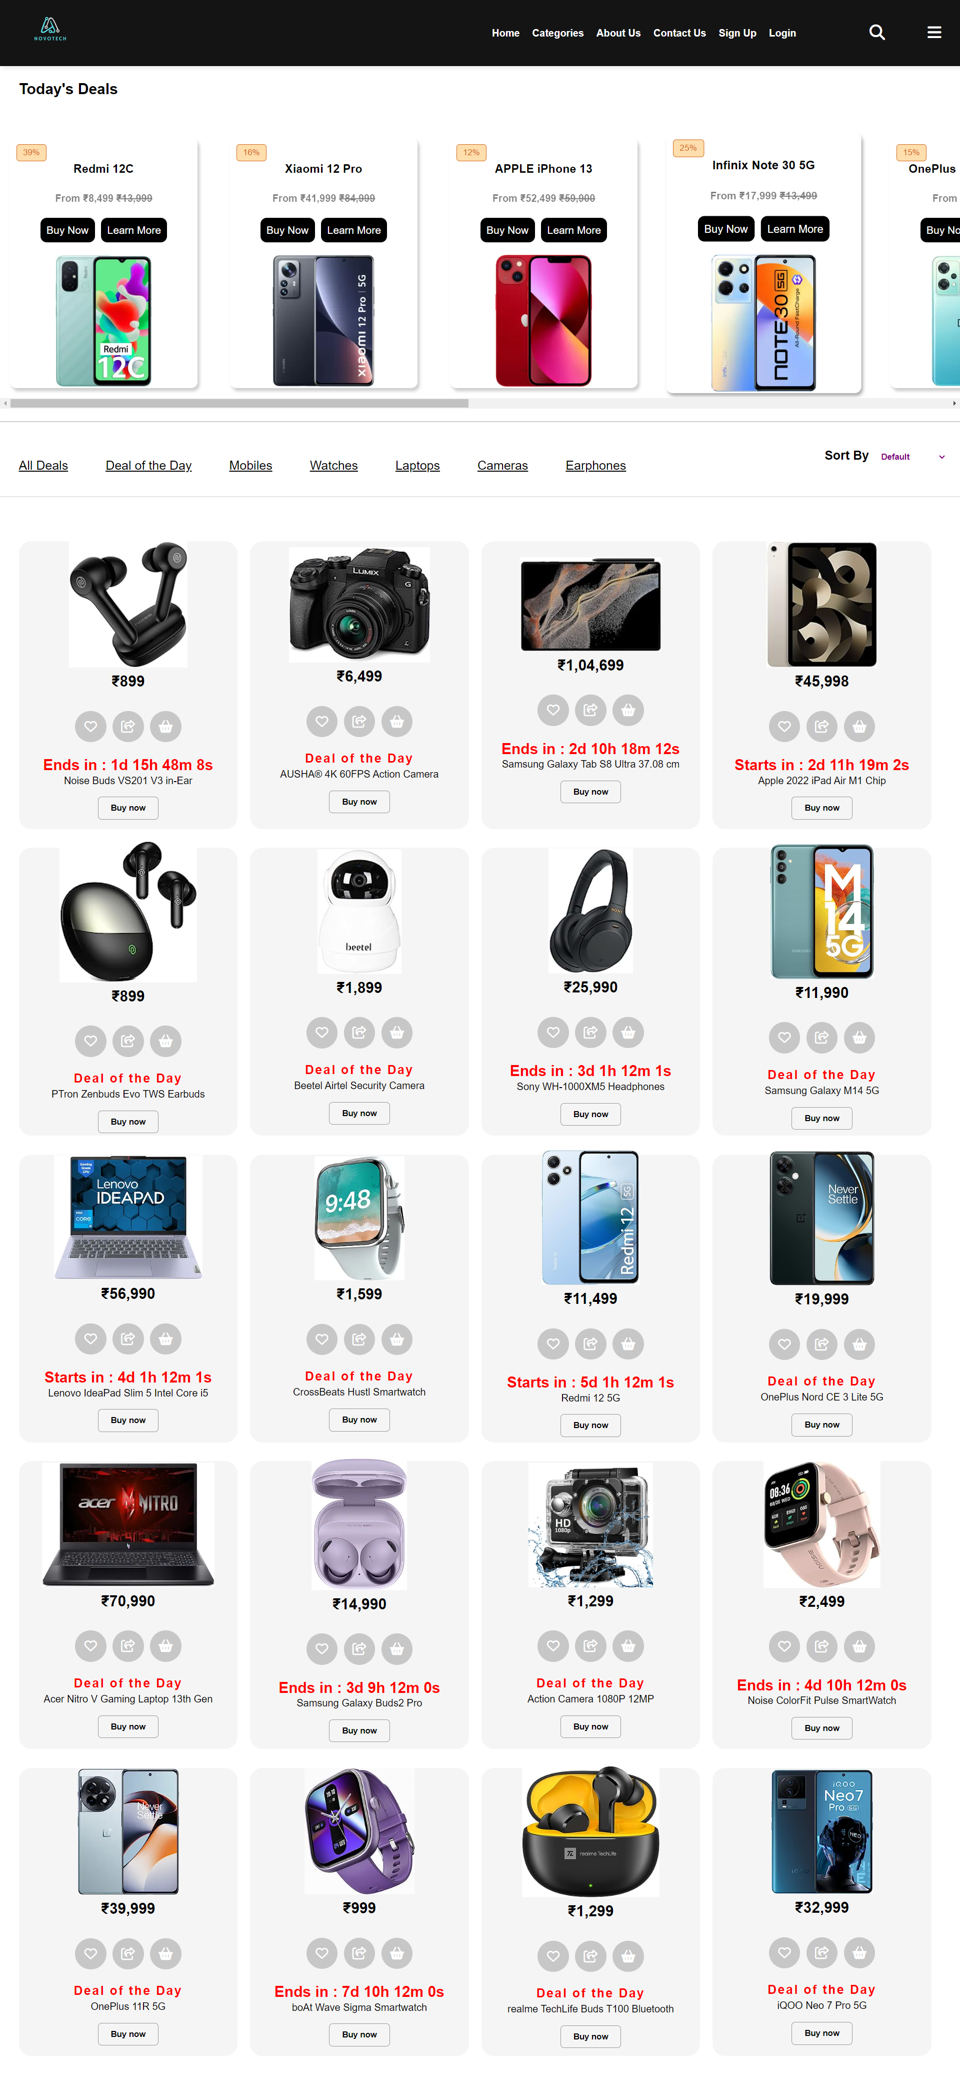

1. The first section introduces "Today's Deals"

2. Second section displays a collection of product cards with images and details of items on sale. These products range from smartphones to

smartwatches and offer discounts, buy now buttons, and countdown timers for limited-time deals.

3. The page also includes filters for sorting deals and uses icons**.**

**Overview of Javascipt of Deals and discount Page:**

**1. Countdown Timers (countDown1, countDown2, ...):**

These sections of code create countdown timers for various events or deals on a web page.

countDownDate1, countDownDate2, etc., represent the target end times for each event, specified as JavaScript Date objects.

setInterval functions are used to update the countdown every second.

Inside the interval function, it calculates the remaining time in days, hours, minutes, and seconds.

The remaining time is displayed in the respective HTML elements with IDs like countdown1, countdown2, etc.

If the countdown reaches zero or goes negative, it displays "EXPIRED" or "DEAL ENDS" as appropriate and stops the countdown.

**2.Sorting and Filtering Products:**

This section handles sorting and filtering products on a web page.

The code runs when the DOM content is fully loaded (DOMContentLoaded event).

It uses a <select> element with the ID "select" to sort products by price (LowToHigh, HighToLow) or original order.

When the user changes the select option, it sorts the product items based on their prices or original order.

The sorted product items replace the existing items in the HTML**.**

**3. Deals and Discounts Filtering:**

This section allows filtering deals and discounts based on categories.

The code runs when the DOM content is fully loaded (DOMContentLoaded event).

It selects elements with class "indicator li" which are likely filter buttons.

When a filter button is clicked, it calls the filterProducts(category) function, passing the selected category.

The filterProducts function hides or displays items based on their data attributes (data-category and data-special) and updates the active filter button.

* 1. **Blog Page:**

1. The main content of the page showcases a section with a tagline, an image, and several cards highlighting blog posts.
2. Each blog card includes a title, a brief description, a publication date, and a "Read More" button.

3. The page is designed to provide information and blog posts related to technology and electronics, maintaining a visually appealing and user-friendly layout.

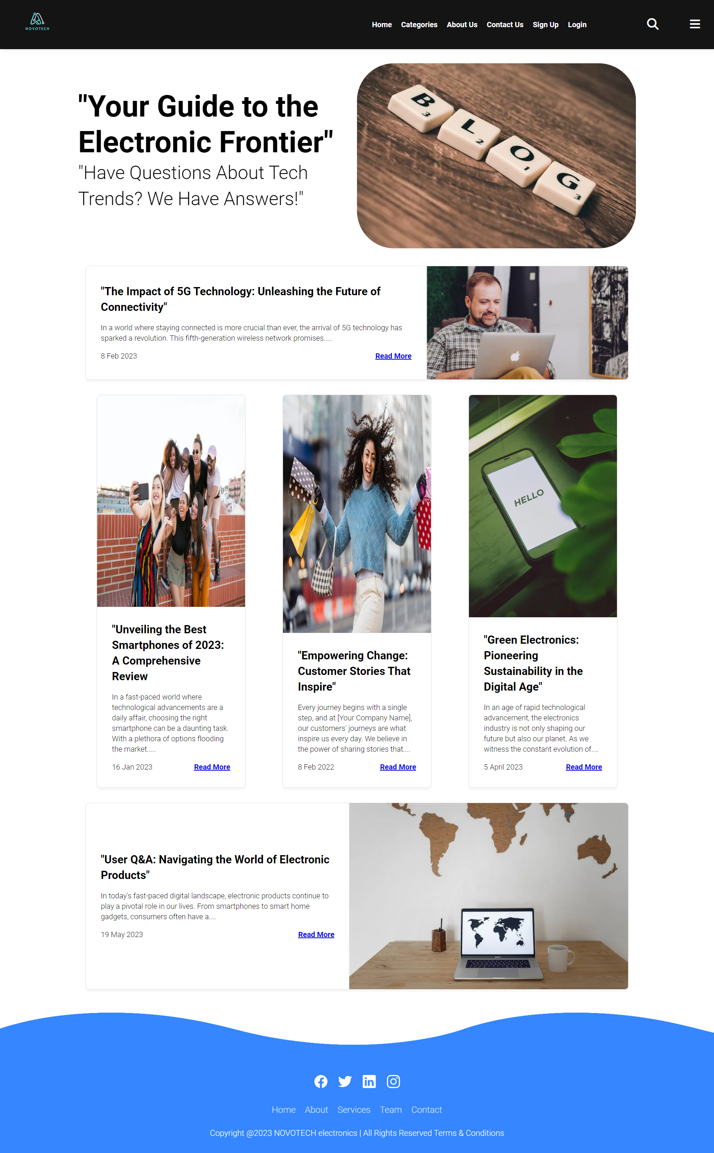

* 1. **Connect With Us Page:**

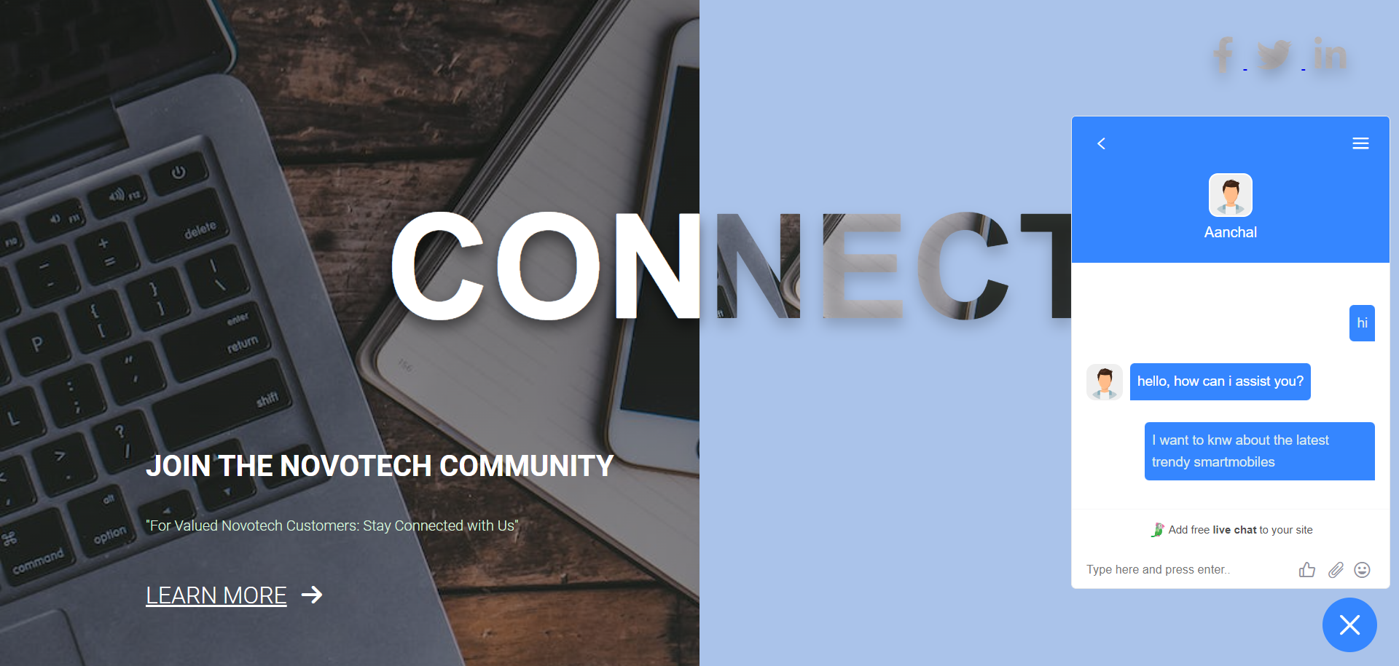

1. The main section of the page is divided into two halves. On the left side, there is a brief

introduction inviting users to join the NOVOTECH community, along with a

"Learn More" link.

2. On the right side, various social media icons are displayed, allowing users to connect with the

organization on platforms like Facebook, Twitter, and LinkedIn.

3. Additionally, the inclusion of a live chat feature from Tawk.to adds an interactive element for

users to engage with the website's administrators in real time. This page

effectively promotes community engagement and connection with the NOVOTECH brand.

* 1. **Product Page:**

1. It includes a detailed product description, images, pricing information, and features for the "beatXP Marv Neo" smartwatch.

2. Users can select different images of the product by clicking on thumbnail images.

3. Additionally, there is a section for comparing this product with similar ones.

4. The page also displays reviews from customers, providing valuable feedback and ratings.

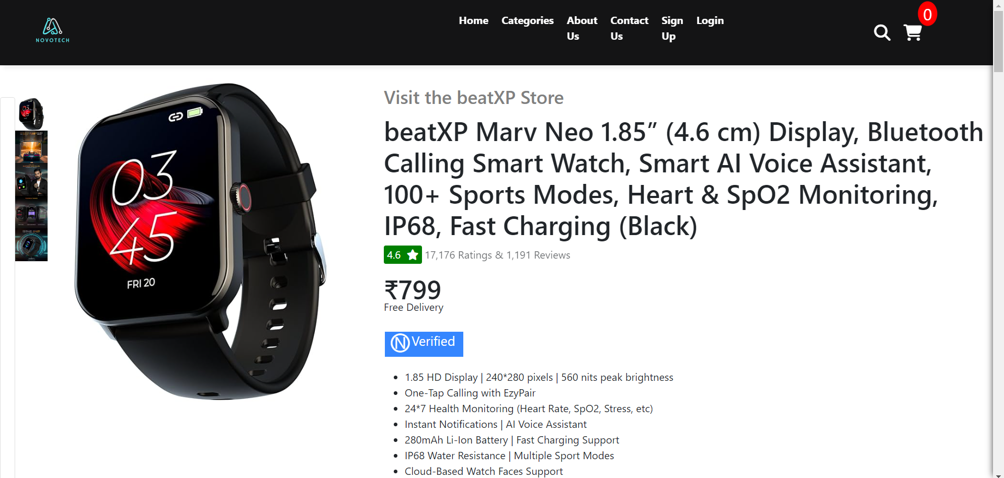

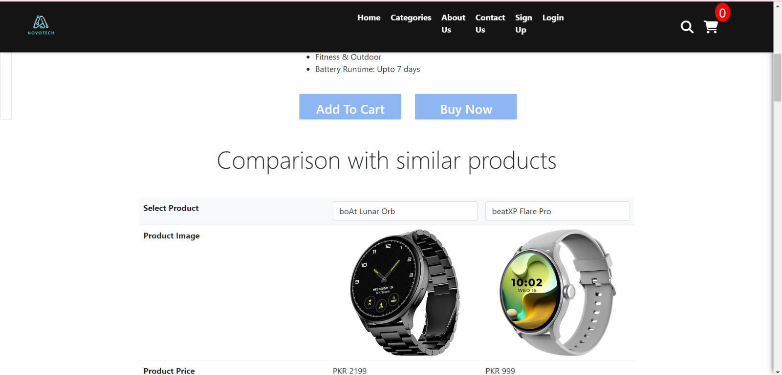

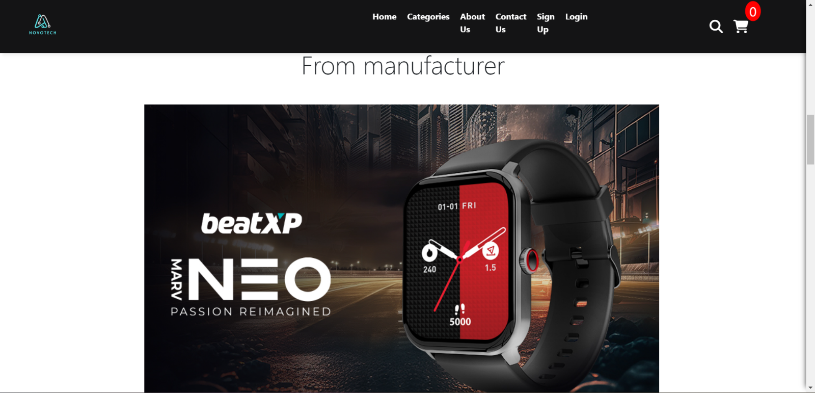

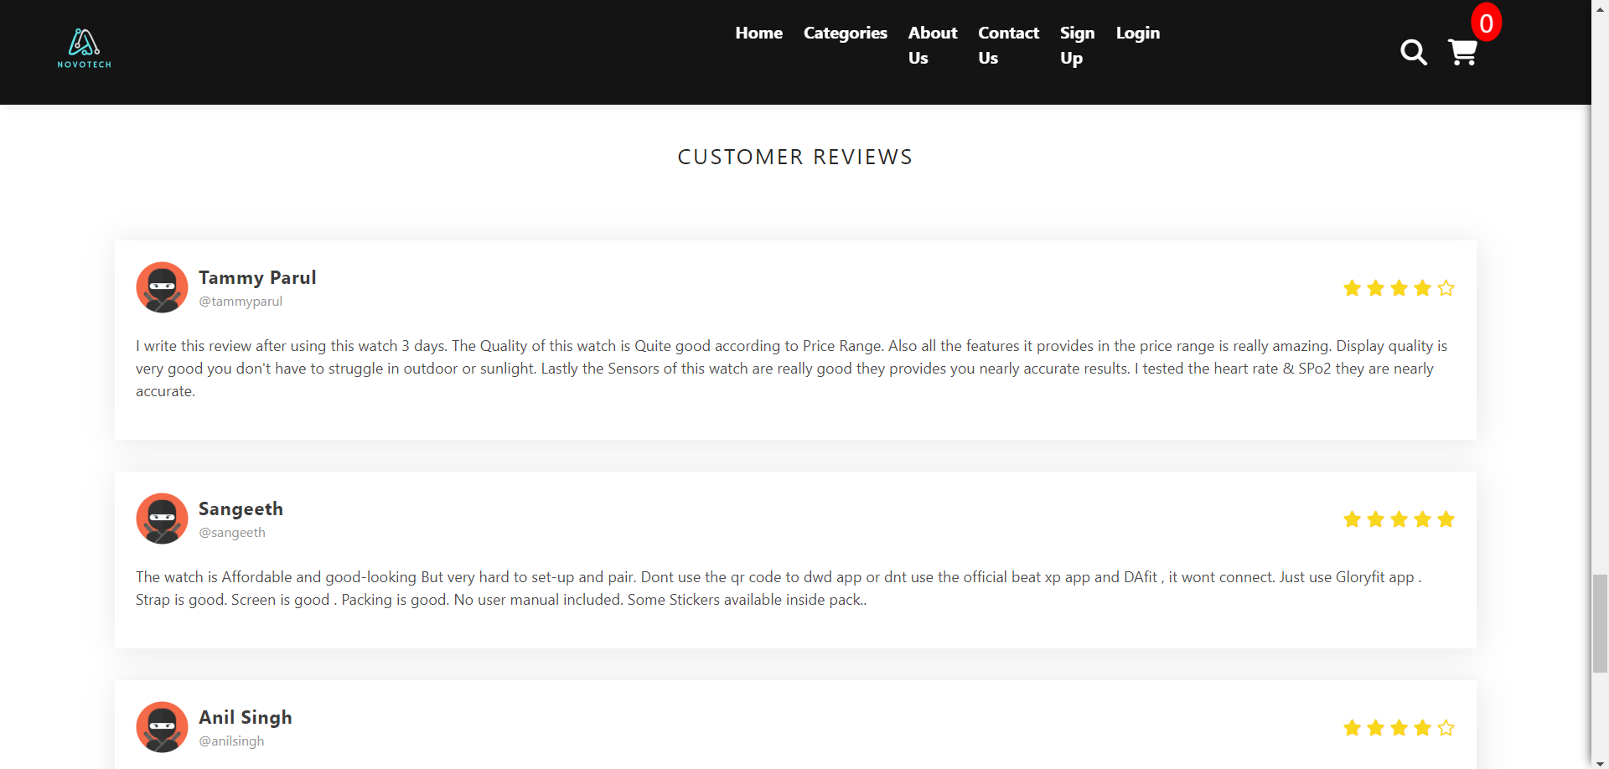

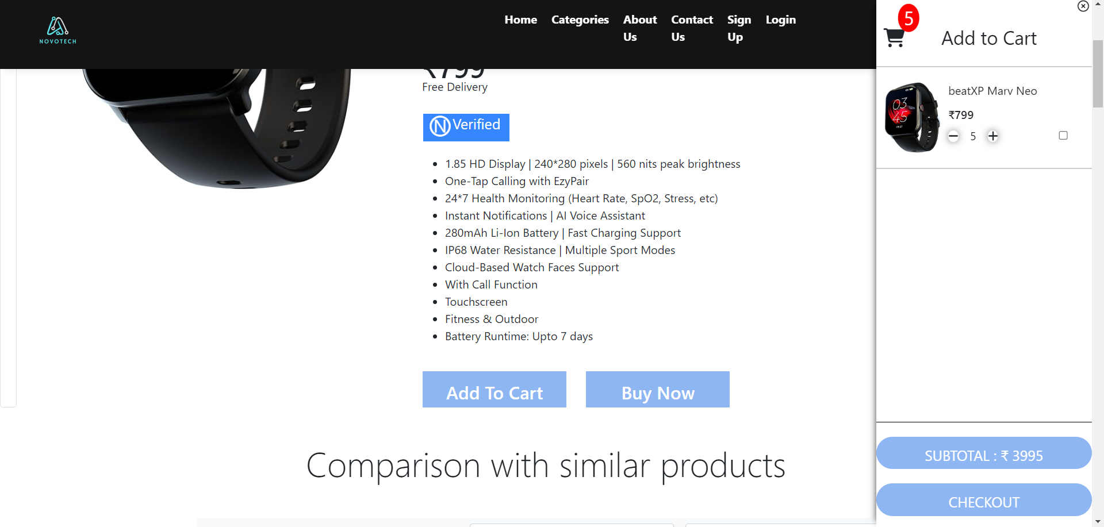

**Overview of javascipt of product page:**

**1. Populating Product Selection Dropdowns:**

The code uses a loop to populate two dropdowns with product options (probably for product comparison) by adding <option> elements with product titles to the HTML select

elements with IDs "select1" and "select2."

**2. Item Selection and Display:**

Two functions, item1 and item2, are defined to handle the selection of items in the dropdowns.

When an item is selected in one dropdown, the corresponding product image, price, description, and brand are updated for that item in the HTML.

If the same item is selected in both dropdowns, it clears the selection and hides the details.

**3. Cart Count Management:**

A function called updateCartCount updates and displays the count of items in the cart.

It also manages the increment and decrement of product counts in the cart.

Plus and minus icons allow users to increase or decrease the count, respectively, with a minimum count of 0.

Product details such as image, price, description, and brand are updated when a user clicks the plus or minus icon.

**4. Cart Drawer:**

A cart drawer is displayed when a user clicks on a cart icon.

Clicking outside the cart drawer closes it.

This allows users to view their selected items and proceed to checkout.

**5. Checkbox Handling:**

Checkboxes are used to select items for the cart.

When a checkbox is checked or unchecked, the updateCart function is called to manage the cart contents and count.

The cart count is increased when a checkbox is checked, and the product details are displayed.

**6. Empty Cart Functionality**:

The code checks for changes in checkboxes, and if a checkbox is unchecked, it hides the corresponding product in the cart and updates the cart count.

**7. Price Update:**

A function updatePrice is defined to display the subtotal price for selected items in the cart.

The code adjusts the price when items are added or removed from the cart.

**8. Event Listeners:**

Event listeners are set up for various elements, such as plus and minus icons for cart item counts, adding items to the cart, and changing the selected product for comparison.

* 1. **Category Page:**

1. The page features a search input for users to search for smartwatches. The main content area showcases a selection of smartwatches with product details, including

images, descriptions, pricing, discounts, and availability information.

2. Each product is presented in a card-like format with user reviews and ratings.

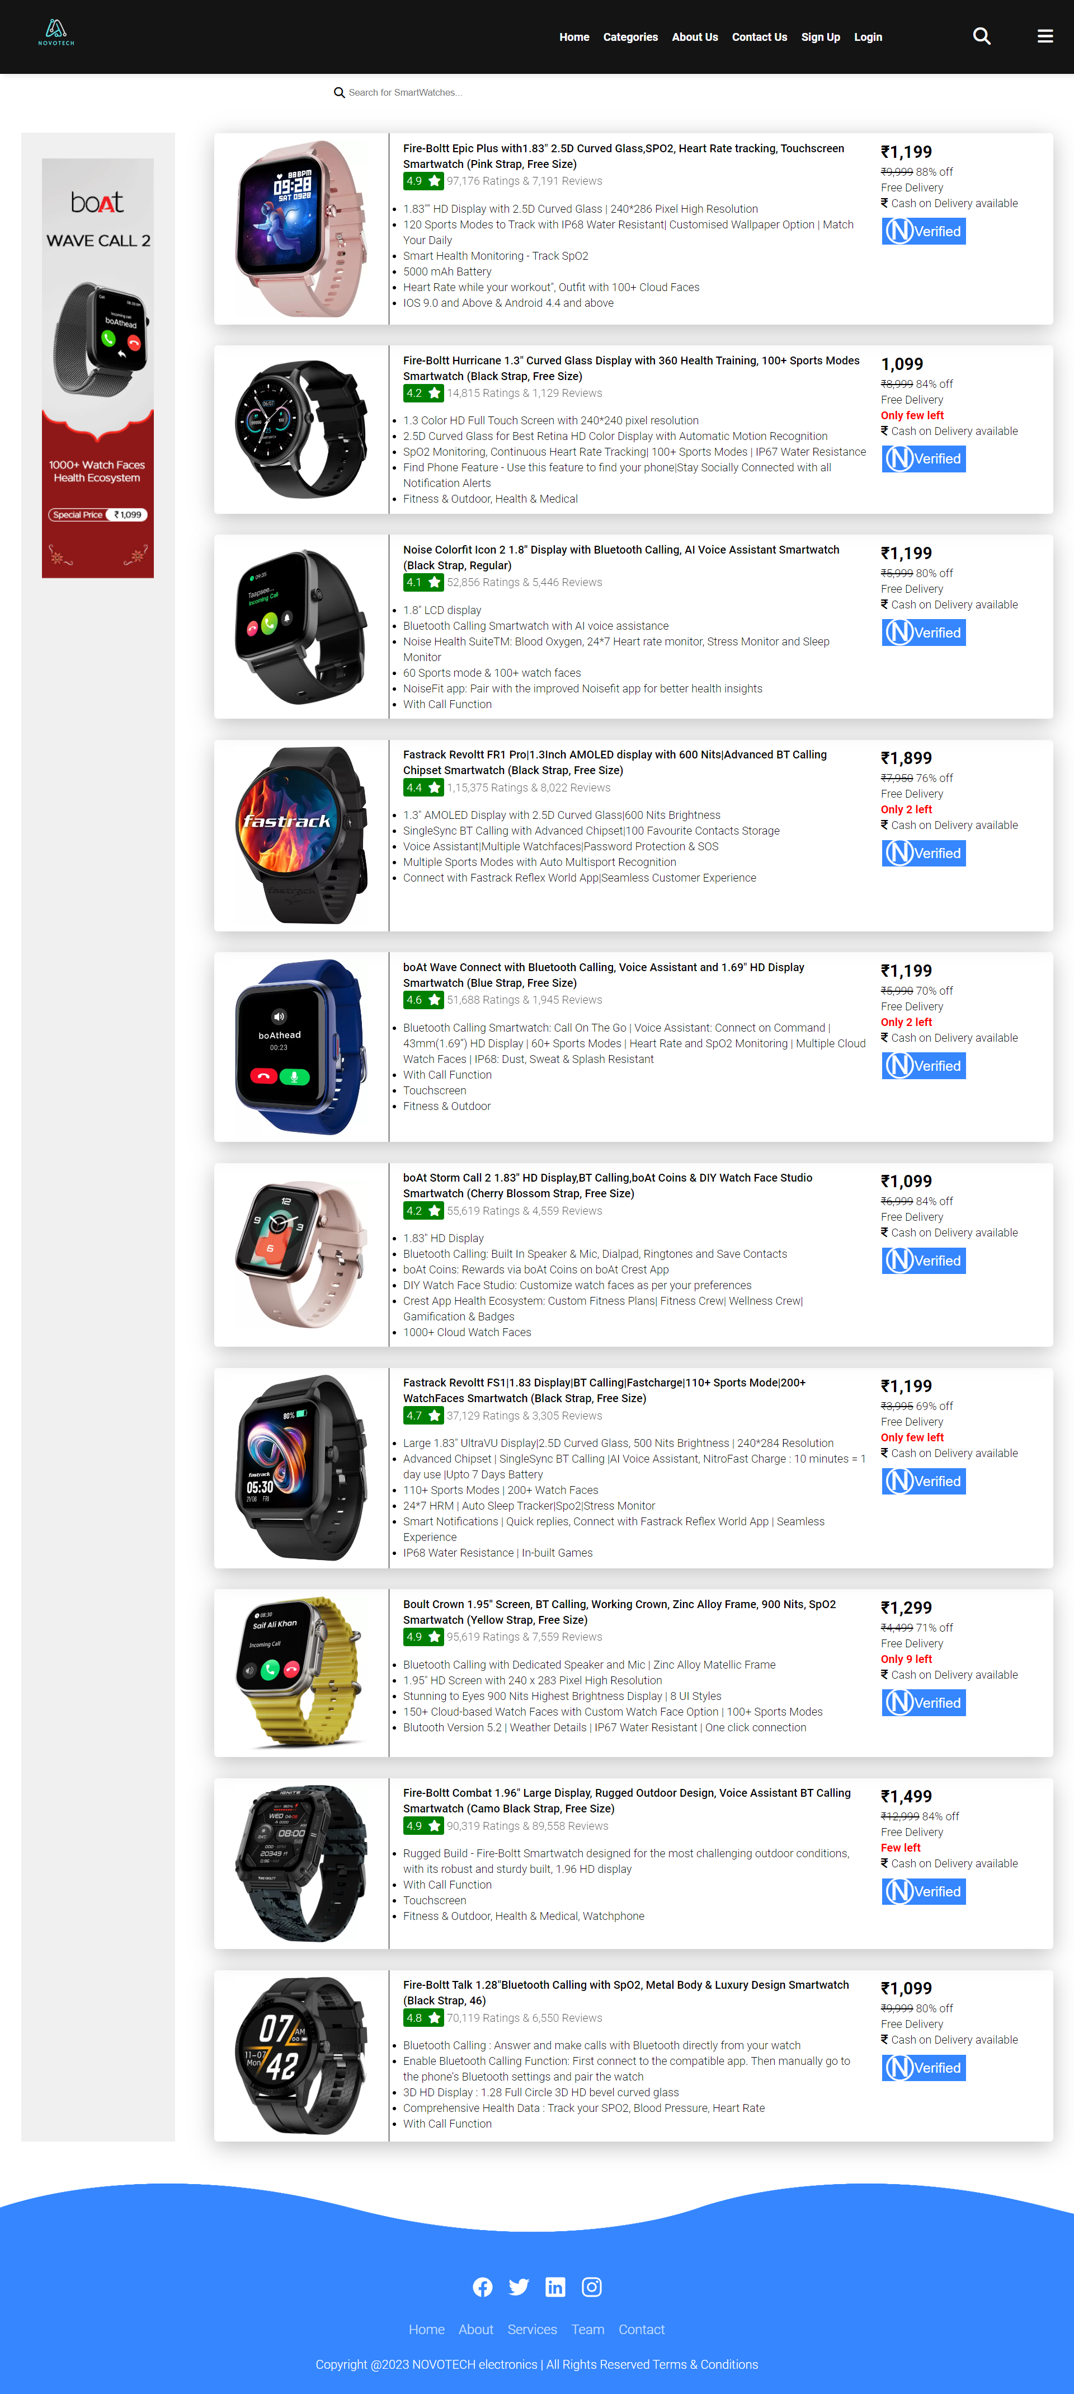

**Overview of Javascript of Category page:**

**1. Event Listener**: The code begins with an event listener that waits for the DOM (Document Object Model) to be fully loaded before executing any JavaScript. This ensures

that the JavaScript code runs when the webpage is ready.

**2. Selecting Elements:** Within this event listener, the code selects several elements using document.querySelector and document.getElementById. These elements include the container for product listings, a search input field, and a collection of product cards**.**

**3. Filtering Products:** The core functionality of the code is in the filterProducts function. This function is responsible for filtering and displaying product cards based on the user's search input.

**4. Search Input Event Listener**: To make the search functionality work, an event listener is added to the search input field. Whenever the user types in the input, this event listener calls the filterProducts function.

* 1. Brand Page:

1. **Main Content** - First Section: The first main section features a large image of an Intel brand logo, possibly indicating a focus on Intel-powered laptops or products. This section is essentially an introductory banner.

2**. Product Showcase**: Following the banner, there are multiple product showcases, each containing an image of a laptop, a discount percentage, product name, original price, and options to "Buy Now" or "Learn More." These products appear to be Intel-based laptops from various brands such as Fujitsu, ASUS, Lenovo, Dell, and Acer.

3. **Image Slideshow**: After the product showcase, there's an image slideshow featuring additional images related to the Intel brand.

4**. Product Field**: This section displays a grid of products, each with an image, price, and option to add to favorites, share, or add to the shopping basket. Products include laptops and computer components, most likely with Intel processors.

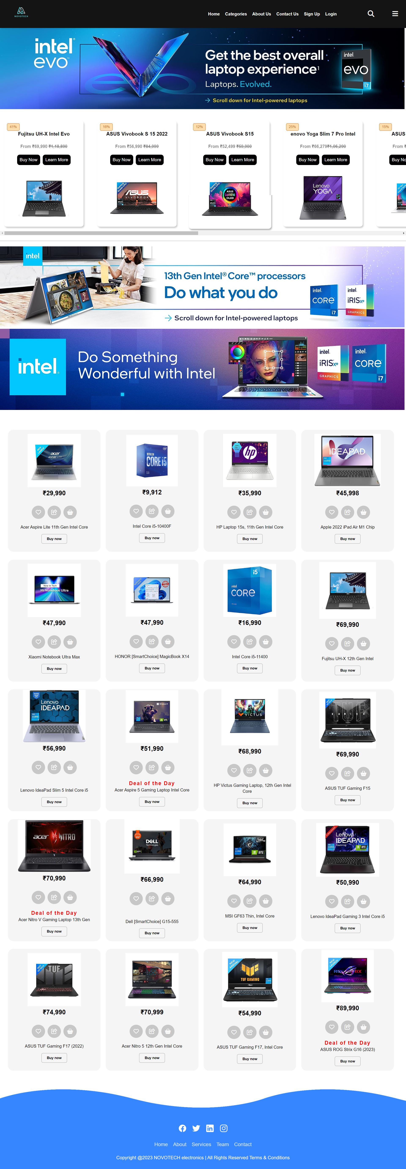

3.11 Checkout Page: 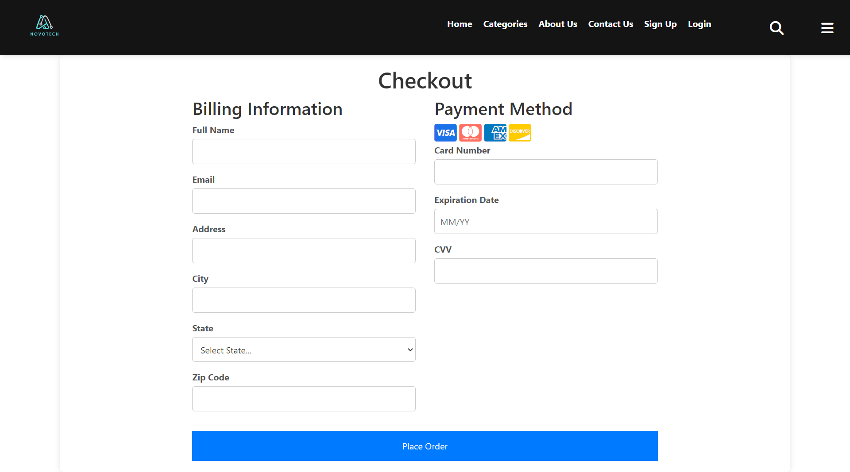

1.It includes sections for billing information and payment methods. The billing information section collects the user's full name, email, address, city, state (with a dropdown list of options), and zip code.

2.The payment method section allows users to enter their card details, including the card number, expiration date, and CVV. There are also card icons for popular card types.

1. When the "Place Order" button is clicked, a JavaScript function triggers a pop-up overlay with a success message, indicating that the order has been placed successfully.

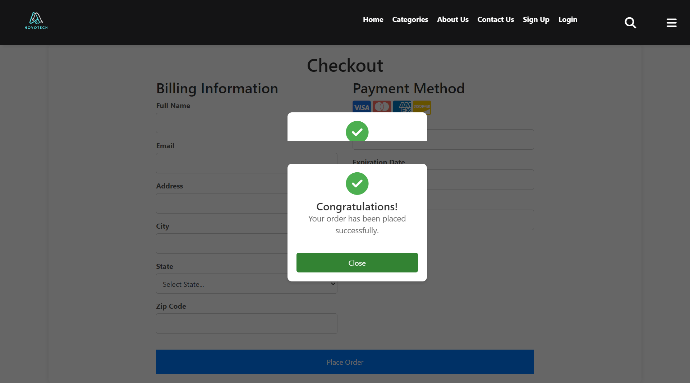

**CHAPTER 4: WHY NAME NOVOTECH?**

The choice of the name *Ambience* for my e-commerce site can be influenced by several factors:

1. **Innovation:** The name "NOVOTECH" suggests innovation and cutting-edge technology. It implies that your website offers the latest and most advanced electronic products, which can be appealing to tech-savvy customers.
2. **Technology**: The name "NOVOTECH" combines "novo," derived from the Latin word "novus" meaning "new" or "innovative," with "tech," a common abbreviation for "technology." Together, they convey the idea of being at the forefront of technological advancements. This combination implies that the website deals with cutting-edge and innovative electronic products.
3. **Global Appeal**: "NOVOTECH" doesn't contain any geographical terms or specific location references. This makes it a globally adaptable name. It doesn't confine your brand to a particular region, making it suitable for international audiences. It's a brand name that doesn't favor one location over another.
4. **Brandability:** "NOVOTECH" is a unique and distinct name. Its uniqueness contributes to its memorability, making it easier for customers to remember. This aids in building a strong brand identity as customers are more likely to recall the name when thinking of electronic products.

**5..Uniqueness**: The name "NOVOTECH" is not a common or overused term. It's distinctive, and there are fewer chances of confusion with other businesses. This distinctiveness is valuable when establishing a unique brand presence.

**6..Suggestive of Expertise**:Suggestive of Expertise: By combining "novo" and "tech," the name "NOVOTECH" implies expertise in new and advanced technology. It suggests that the website's creators or owners are knowledgeable and experienced in the electronic and tech industry, which can build trust and confidence in potential customers.

**CHAPTER 5: Future Scope**

* **Mobile App Development:** We will consider developing a dedicated mobile application for *Ambience* to provide a seamless and optimized shopping experience for mobile users.
* **Personalization and AI:** Implementing advanced personalization techniques and artificial intelligence to provide customers with product recommendations, personalized content, and a tailored shopping experience.
* **Progressive Web App (PWA):** Transforming the website into a PWA to offer offline access, push notifications, and a more app-like experience for users.
* **Augmented Reality (AR) Integration:** Allowing customers to visualize appliances in their own space using AR technology, which can enhance the decision-making process.
* **Voice Commerce:** Enabling voice search and voice-assisted shopping for hands-free browsing and ordering through voice-activated devices.
* **Subscription Models:** Introducing subscription services for regular appliance maintenance, filter replacements, or exclusive access to new products.
* **Global Expansion:** We will consider expanding our e-commerce platform to serve customers in different regions and countries to tap into a broader market.
* **Cross-Selling and Upselling:** Develop cross-selling and upselling strategies to increase the average order value by recommending related products or premium versions.
* **Enhanced Analytics and Data Insights:** Utilize advanced analytics tools to gain insights into user behaviour, sales patterns, and inventory management, which can guide business decisions.
* **Social Commerce:** Integrating social media features to allow users to discover products through social networks, share their purchases, and interact with our brand on social platforms.